Load Balancers

A load balancer distributes user traffic across multiple instances of your applications. By spreading the load, load balancing reduces the risk that your applications experience performance issues.

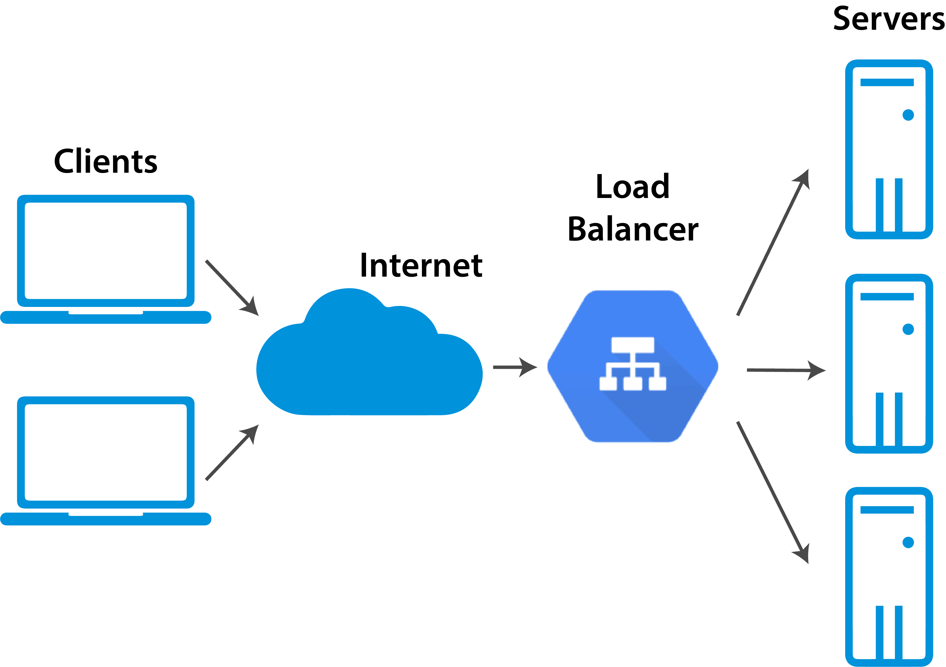

**What is Load Balancer?**

**Load balancing** refers to efficiently distributing incoming network traffic across a group of backend servers, also known as a server farm or server pool.

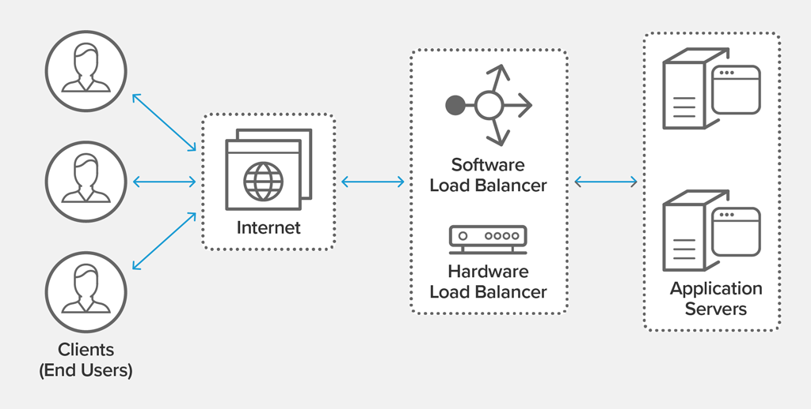

**why we are going for Load Balancers ?**



1. There is a limitation to the number of requests a single computer can handle at a given time.
2. When faced with a sudden surge in requests, your application will load slowly, the network will time out, and your server will creak. You have two options: scale up or scale out.
3. When you scale up (vertical scale), you increase the capacity of a single machine by adding more storage (Disk) or processing power (RAM, CPU) to an existing single machine as needed on demand. But scaling up has a limit — you’ll get to a point where you cannot add more RAM or CPUs.
4. A better strategy is to scale out (horizontal scale), which involves the distribution of loads across as many servers as necessary to handle the workload. In this case, you can scale infinitely by adding more physical machines to an existing pool of resources.
5. Google Cloud Platform (GCP) users effectively balance workloads with managed services. Google Cloud Load Balancer monitoring distributes traffic across multiple instances of applications in a few different ways.

**Types of Load Balancers:**

Google Cloud Load Balancer Types:

1. Global Load Balancing (GLB)
2. External Load Balancing (ELB)
3. Internal Load Balancing (ILB)
4. Google Cloud SSL Load Balancer

**Global Load Balancing (GLB)**

Global server load balancing (GSLB) refers to the intelligent distribution of traffic across server resources located in multiple geographies. The servers can be on premises in a company's own data centers, or hosted in a private cloud or the public cloud.

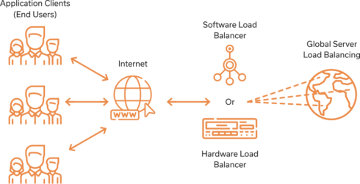

**External Load Balancing (ELB)**

The external load balancer is used to route external HTTP traffic into the cluster. The internal load balancer is used for internal service discovery and load balancing within the cluster.

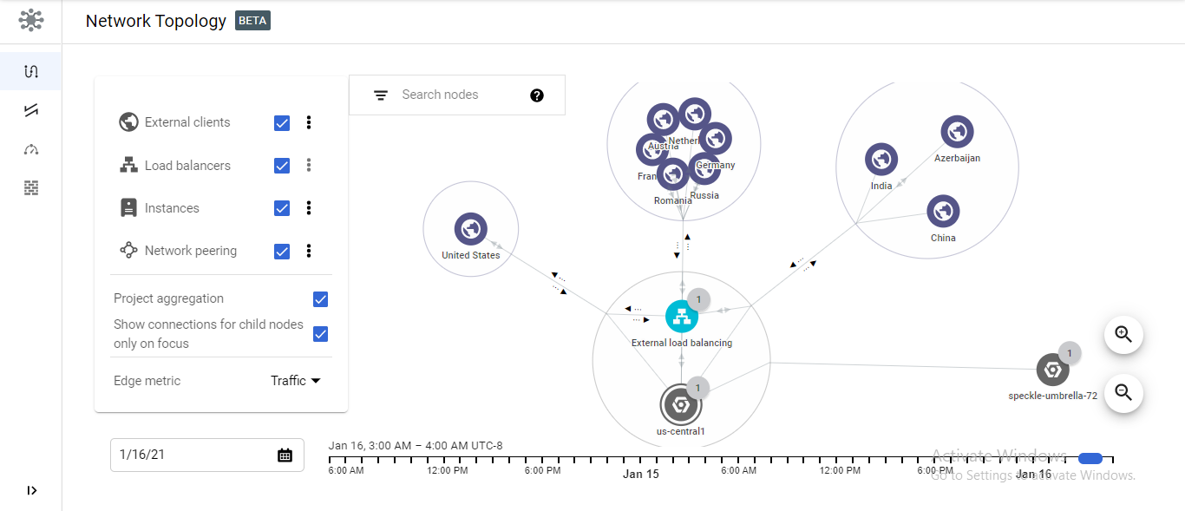

**Internal Load Balancing (ILB)**

An internal (or private) load balancer is used where private IPs are needed at the frontend only. Internal load balancers are used to load balance traffic inside a virtual network. A load balancer frontend can be accessed from an on-premises network in a hybrid scenario

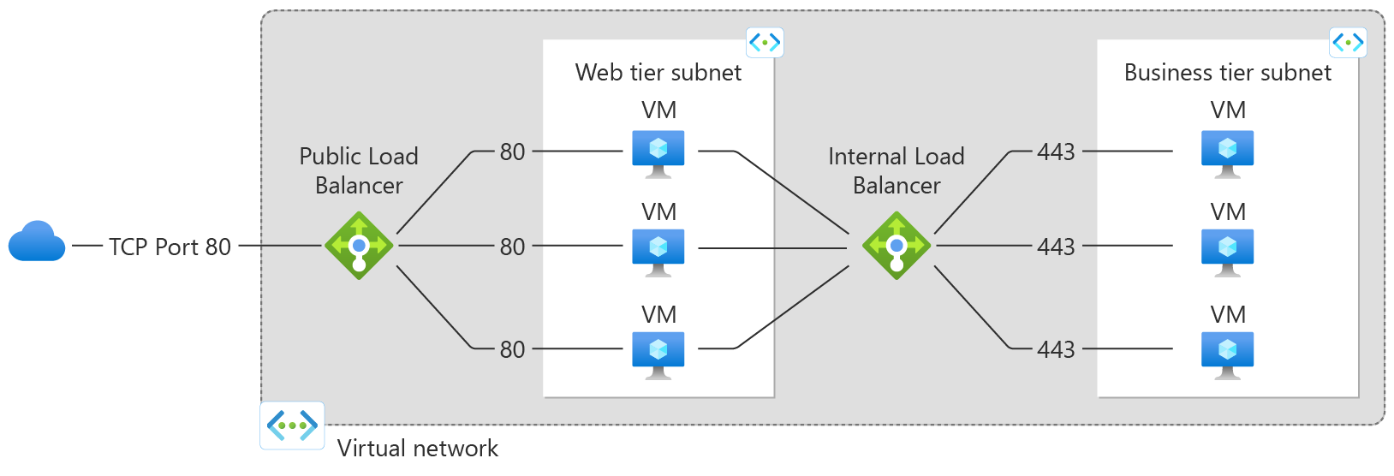

**Google Cloud SSL Load Balancer**

An SSL load balancer is a load balancer that also performs encryption and decryption of data transported via HTTPS, which uses the Secure Sockets Layer (SSL) protocol (or its successor, the Transport Layer Security [TLS] protocol) to secure HTTP data as it crosses the network.

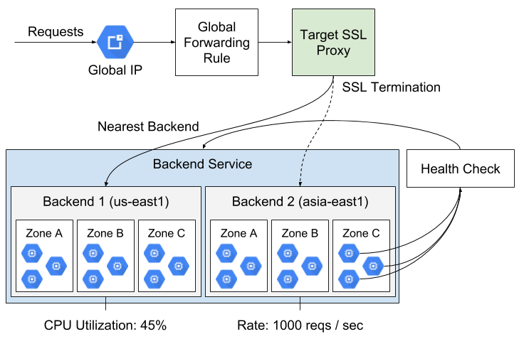

**What is the purpose of load balancer?**

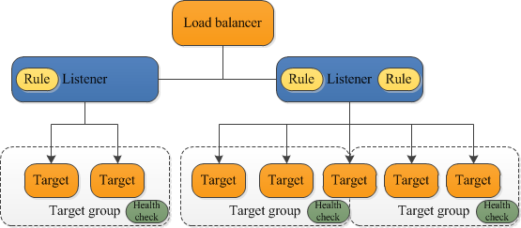

A load balancer serves as the single point of contact for clients. The load balancer distributes incoming application traffic across multiple targets, such as EC2 instances, in multiple Availability Zones. This increases the availability of your application.

* Distributes user traffic across instances of an application in single region or multiple regions
  + **Fully distributed, software defined** managed service
  + Important Features:
    - Health check - Route to healthy instances
      * Recover from failures
    - Auto Scaling
    - Global load balancing with single anycast IP
      * Also supports internal load balancing
* Enables:
  + High Availability
  + Auto Scaling
  + Resiliency

**Advantages of Load Balancers:**

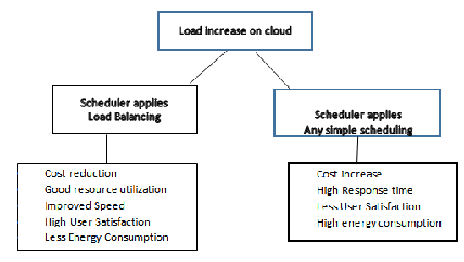

1. Increased Scalability
2. Redundancy
3. Reduced Downtime, Increased Performance
4. Efficiently Manages Failures
5. Increased Flexibility

**DisAdvantages :**

#### 1.Single point of failure

#### 2.Virtual Machine migration

#### 3. Heterogeneous nodes

#### 4. Storage management

#### 5.Complexity of algorithms